**RIPHAH INTERNATIONAL UNIVERSITY, ISLAMABAD**



**Lab 8**

**Bachelors of Computer science – 6th semester**

**Subject:** Artificial Intelligence Lab

**Submitted to:** Ma’am Ayesha

**Submitted by:** Areeba Sadaqat

**Sap Id:** 47633

**Date:** 25th March, 2025

**Tasks**

**Question 01:**

Write a program for a simple reflex agent. The agent will act as a vacuum cleaner. In the first activity, we will create an environment for the agent.

* The environment is divided into 4 portions A,B,C and D.
* Then define two states for each portion.
* 0 indicates the cleaned state and 1 indicates the dirty state.
* We will initialize each portion with a random state that would be either 0 or 1.

**Code:**

import random

def initialize_environment():

# Creating an environment with random states (0: Clean, 1: Dirty)

return {"A": random.randint(0, 1),

"B": random.randint(0, 1),

"C": random.randint(0, 1),

"D": random.randint(0, 1)}

def vacuum_cleaner(environment):

for location, state in environment.items():

print(f"Vacuum is at {location}. State: {'Dirty' if state == 1 else 'Clean'}")

if state == 1:

print(f"Cleaning {location}...")

environment[location] = 0 # Clean the location

print(f"{location} is now clean.\n")

def main():

environment = initialize_environment()

print("Initial Environment State:")

print(environment, "\n")

vacuum_cleaner(environment)

print("Final Environment State:")

print(environment)

if __name__ == "__main__":

main()

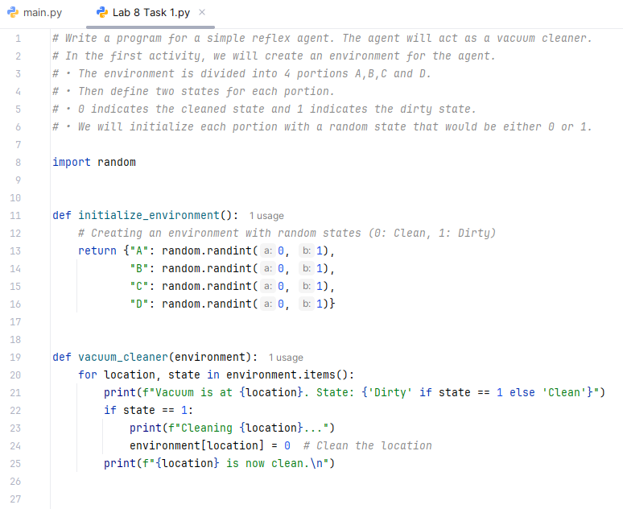 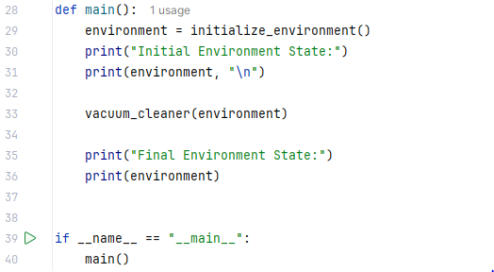

**Output:**

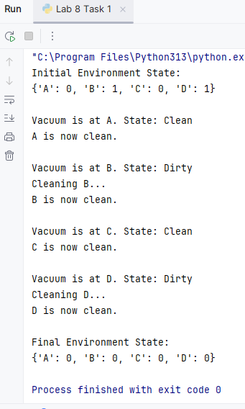

**Question 02:**

Create a Simple Reflex Agent that:

* Observes traffic light color (red, yellow, green).
* Takes an action based on the light:

Red → Stop

Yellow → Slow down

Green → Move

**Code:**

import random

def get_traffic_light():

# Randomly selecting a traffic light color

return random.choice(["Red", "Yellow", "Green"])

def reflex_agent(light_color):

actions = {

"Red": "Stop",

"Yellow": "Slow down",

"Green": "Move"

}

return actions.get(light_color, "Unknown action")

def main():

light_color = get_traffic_light()

print(f"Traffic Light: {light_color}")

action = reflex_agent(light_color)

print(f"Agent Action: {action}")

if __name__ == "__main__":

main()

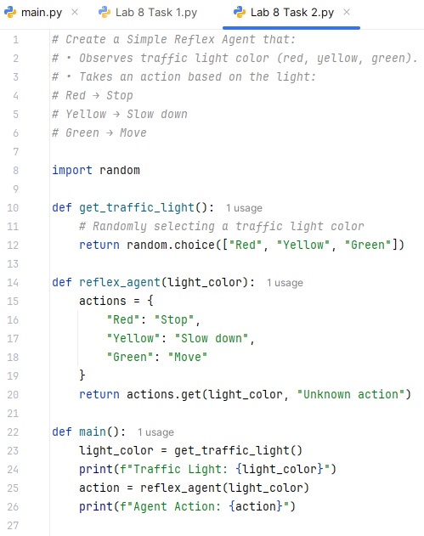 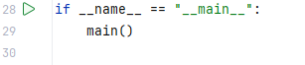

**Output:**

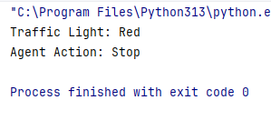

**Question 03:**

Implement an automatic door agent that:

* Opens if it detects a person near the door.
* Closes if no person is detected.

Add a security feature where the door stays closed at night unless an authorized person is detected.

**Code:**

import time  
  
  
class AutomaticDoor:  
 def __init__(self):  
 self.is_open = False  
 self.authorized_persons = {"Alice", "Bob"} *# List of authorized persons* def is_night_time(self):  
 current_hour = time.localtime().tm_hour  
 return current_hour >= 20 or current_hour < 6 *# Nighttime from 8 PM to 6 AM* def detect_person(self, person=None):  
 if self.is_night_time():  
 if person in self.authorized_persons:  
 self.open_door()  
 else:  
 self.close_door()  
 else:  
 if person:  
 self.open_door()  
 else:  
 self.close_door()  
  
 def open_door(self):  
 if not self.is_open:  
 self.is_open = True  
 print("Door is now OPEN.")  
  
 def close_door(self):  
 if self.is_open:  
 self.is_open = False  
 print("Door is now CLOSED.")  
  
  
*# Simulation*door = AutomaticDoor()  
  
test_cases = [None, "Alice", "Bob", "Unknown"]  
  
for person in test_cases:  
 print(f"Detecting: {person}")  
 door.detect_person(person)  
 time.sleep(1) *# Simulate time delay*

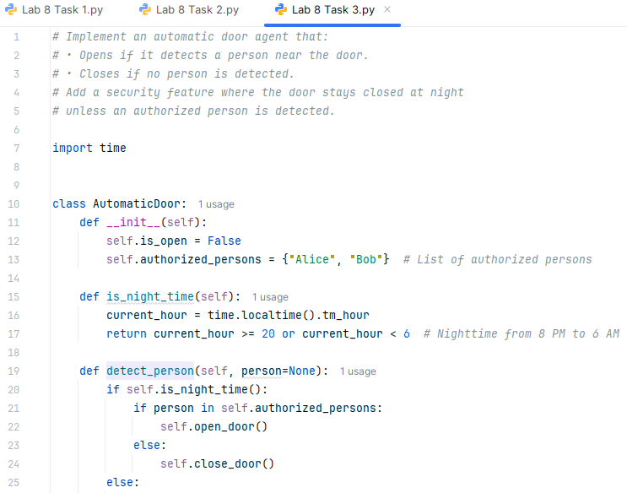 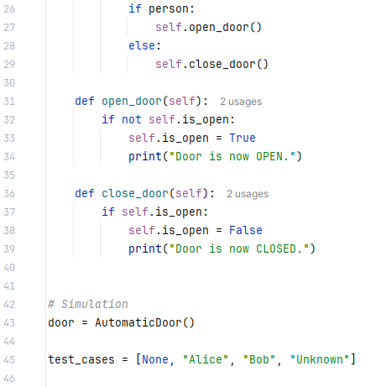 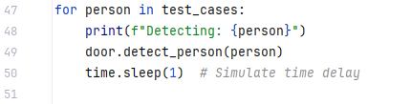

**Output:**

